Andey Ng

TP1 Write Up

* + **Project Description** [5 pts]: The name of the term project and a short description of what it will be.

Andey’s Arcade will consist of multiple games such as a “Streetfighter” version of *The Last Airbender* that the user can play/control with the Kinect.

* + **Competitive Analysis** [5 pts]: A 1-2 paragraph analysis of similar projects you've seen online, and how your project will be similar or different to those.

*The Last Airbender* is every millennial’s childhood favorite. *The Last Airbender* is currently developing their live-action animation; however, there are no interactive games to help hype their release to the public. Because there are currently no *Avatar: The Last Airbender* games that allow players to become their favorite character, this project will fulfill every child’s dream of waterbending in the showers or firebending in thin air. This project will mimic Streetfighter’s game; however, there will be different powers and players.

Many of the games we grew up playing are played through controllers; however, there is a lack of games which are virtually controlled by a user’s motions. By developing an arcade which players can choose their favorite games, they are able to interact with the games and *become* their players.

* + **Structural Plan** [5 pts]: A structural plan for how the finalized project will be organized in different functions, files and/or objects.

The game will require multiple objects, mainly a CPU which will have AI implemented to evaluate the player’s moves and become stronger and defeat the user. I will need to place parameters/rules of the game to assure that the AI can make proper calculations.

The player should be controlling a sprite displayed on Pygame through the player’s motions on the Kinect.

For other games in the arcade, the player should control the pieces with the Kinect through drag-and-drop motions.

The changing screens require me to implement a “splash screen” that can switch scenes.

* + **Algorithmic Plan** [5 pts]: A detailed algorithmic plan for how you will approach the trickiest part of the project.

The most complex part of my project is to understand how to use the Kinect to interact with my Pygame screen. Because the Kinect has been discontinued, understanding the documentation of how to make the player control the Pygame objects with the Kinect will be tedious.

Training the CPU to defeat the user through AI will be difficult as well.

* + **Timeline Plan** [5 pts]: A timeline for when you intend to complete the major features of the project.

11/24/18: Finish Pygame character controlled by keys and Kinect Motions

11/30/18: Kinect motions can control sprites on the screen of Pygame

12/07/18: Splash screens, multiplayer and AI half way done

12/12/18: AI completed, Video finishing up

* + **Version Control Plan** [3 pts]: A short description and image demonstrating how you are using version control to back up your code. **You must back up your code somehow!!!**

I am using GitHub to upload all my files.

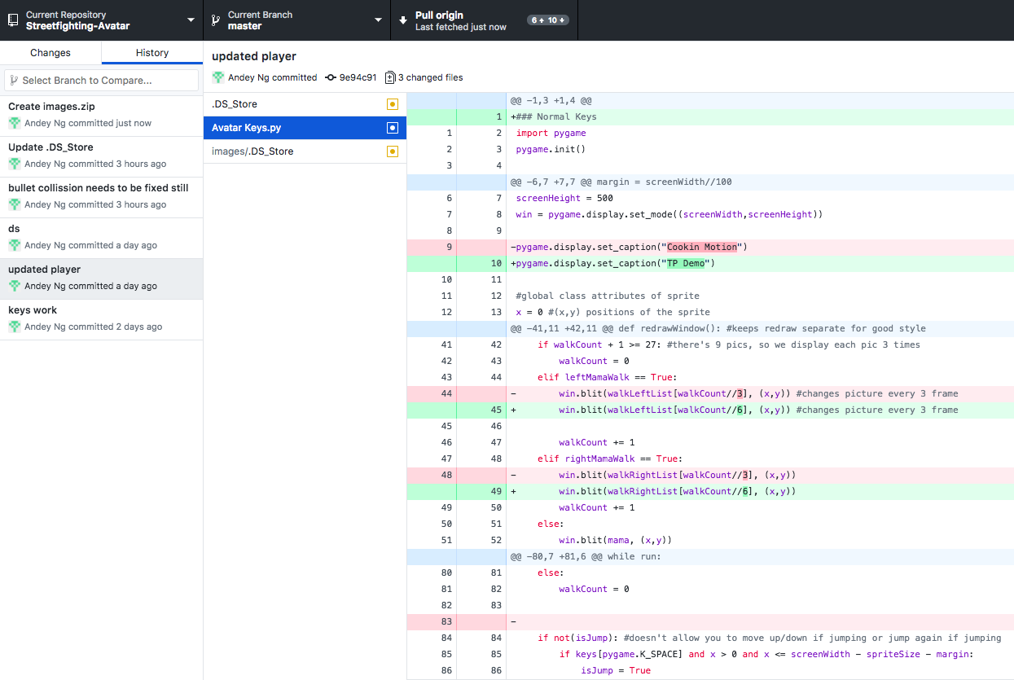

* + **Module List** [2 pts]: A list of all external modules/hardware/technologies you are planning to use in your project. Note that any such modules must be approved by a tech demo. If you are not planning to use any additional modules, that's okay, just say so!
    - Microsoft Kinect sensor
    - PyKinect2
    - Pygame